Mother’s Day Breakfast

Be it Mother’s Day, a Birthday or just a Special Day for Mom, Grandma, Aunt or even Dad. You can make that Special someone an easy fun Breakfast to start their day out!

Here are some easy and quick idea’s:
Scramble and egg, a piece of toast, a Slice of Bacon or Sausage. Add a glass of orange juice.  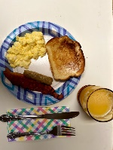 | A bowl of oatmeal, even instant. Slice up some banana or strawberries on the side. Do not forget a glass of milk.  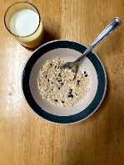
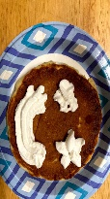  Pancakes and Waffles are easy. What do you have? Make them from a mix or frozen. Add some fresh fruit, blueberries, strawberries, banana? Making them add a few chocolate chips. Do you put peanut butter on them? Use whip cream and make a happy face. Do not forget the syrup! Be creative. Do not forget your drink, coffee, tea? | French Toast? Easy to make they even come in sticks frozen, with cinnamon. Add a slice of bacon or a sausage. How about some fresh fruit? Cantaloupe, honeydew, watermelon? Just like pancakes don’t forget the syrup and drink.  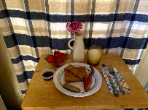
Want to go simple. A bowl of cereal. Put a cup of milk on the side so cereal does not get soggy.  It does not make a difference what you do it is the thought that counts.  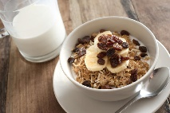  This Photo by Unknown Author is licensed under CC BY | So Many ideas! Use a Bed Tray, Tv tray or just make a nice spot at your table. Do not have a table, throw a blanket on the floor and make a breakfast picnic! Have a vase or plastic cup? Put some fresh flowers, or even just one flower in it. Do not have any make a paper one or two. Make a card, the best cards are not store bought!  Be Creative! Have fun with it! Enjoy!  Make their Day Start with a Smile!  Don’t forget to clean up!
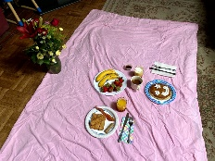  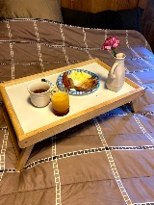 | 